Data models define how the logical structure of a database is modeled. Data Models are fundamental entities to introduce abstraction in a DBMS. Data models define how data is connected to each other and how they are processed and stored inside the system.

The very first data model could be flat data-models, where all the data used are to be kept in the same plane. Earlier data models were not so scientific, hence they were prone to introduce lots of duplication and update anomalies.

**Entity-Relationship Model**

Entity-Relationship (ER) Model is based on the notion of real-world entities and relationships among them. While formulating real-world scenario into the database model, the ER Model creates entity set, relationship set, general attributes and constraints.

ER Model is best used for the conceptual design of a database.

ER Model is based on −

* **Entities** and their *attributes.*
* **Relationships** among entities.

These concepts are explained below.

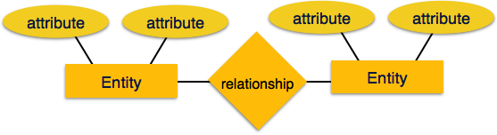

* **Entity** − An entity in an ER Model is a real-world entity having properties called **attributes**. Every **attribute** is defined by its set of values called **domain**. For example, in a school database, a student is considered as an entity. Student has various attributes like name, age, class, etc.
* **Relationship** − The logical association among entities is called ***relationship***. Relationships are mapped with entities in various ways. Mapping cardinalities define the number of association between two entities.

Mapping cardinalities −

* + one to one
  + one to many
  + many to one
  + many to many

**Relational Model**

The most popular data model in DBMS is the Relational Model. It is more scientific a model than others. This model is based on first-order predicate logic and defines a table as an **n-ary relation**.

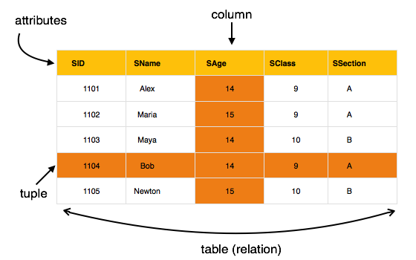

The main highlights of this model are −

* Data is stored in tables called **relations**.
* Relations can be normalized.
* In normalized relations, values saved are atomic values.
* Each row in a relation contains a unique value.
* Each column in a relation contains values from a same domain.

# Data modeling

From Wikipedia, the free encyclopedia

[Jump to navigation](https://en.wikipedia.org/wiki/Data_modeling#mw-head) [Jump to search](https://en.wikipedia.org/wiki/Data_modeling#p-search)

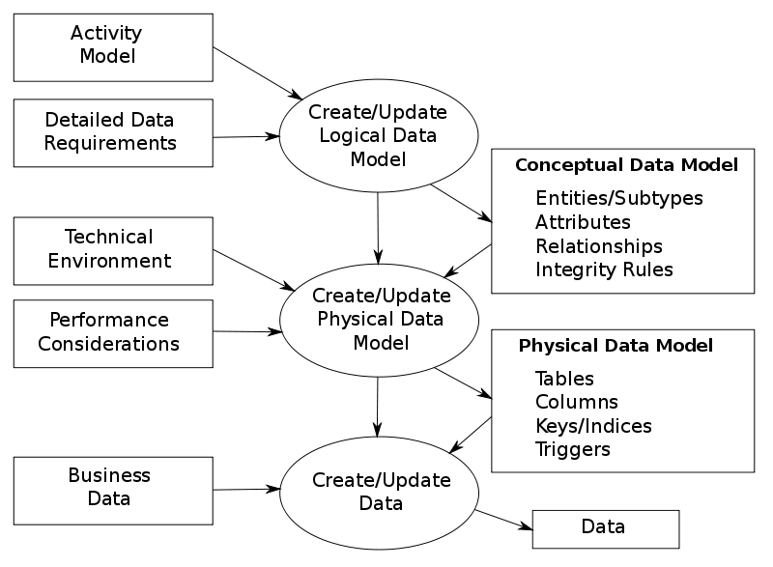

The data modeling process. The figure illustrates the way data models are developed and used today. A [conceptual data model](https://en.wikipedia.org/wiki/Conceptual_schema) is developed based on the data [requirements](https://en.wikipedia.org/wiki/Requirement) for the application that is being developed, perhaps in the context of an [activity model](https://en.wikipedia.org/wiki/Activity_diagram). The data model will normally consist of entity types, attributes, relationships, integrity rules, and the definitions of those objects. This is then used as the start point for interface or database design.[[1]](https://en.wikipedia.org/wiki/Data_modeling#cite_note-MW99-1)

**Data modeling** in [software engineering](https://en.wikipedia.org/wiki/Software_engineering) is the process of creating a [data model](https://en.wikipedia.org/wiki/Data_model) for an [information system](https://en.wikipedia.org/wiki/Information_system) by applying certain formal techniques.



## Contents

* [1 Overview](https://en.wikipedia.org/wiki/Data_modeling#Overview)
* [2 Data modeling topics](https://en.wikipedia.org/wiki/Data_modeling#Data_modeling_topics)
  + [2.1 Data models](https://en.wikipedia.org/wiki/Data_modeling#Data_models)
  + [2.2 Conceptual, logical and physical schemas](https://en.wikipedia.org/wiki/Data_modeling#Conceptual,_logical_and_physical_schemas)
  + [2.3 Data modeling process](https://en.wikipedia.org/wiki/Data_modeling#Data_modeling_process)
  + [2.4 Modeling methodologies](https://en.wikipedia.org/wiki/Data_modeling#Modeling_methodologies)
  + [2.5 Entity relationship diagrams](https://en.wikipedia.org/wiki/Data_modeling#Entity_relationship_diagrams)
  + [2.6 Generic data modeling](https://en.wikipedia.org/wiki/Data_modeling#Generic_data_modeling)
  + [2.7 Semantic data modeling](https://en.wikipedia.org/wiki/Data_modeling#Semantic_data_modeling)
* [3 See also](https://en.wikipedia.org/wiki/Data_modeling#See_also)
* [4 References](https://en.wikipedia.org/wiki/Data_modeling#References)
* [5 Further reading](https://en.wikipedia.org/wiki/Data_modeling#Further_reading)
* [6 External links](https://en.wikipedia.org/wiki/Data_modeling#External_links)

## Overview

Data modeling is a [process](https://en.wikipedia.org/wiki/Software_development_process) used to define and analyze data [requirements](https://en.wikipedia.org/wiki/Requirement) needed to support the [business processes](https://en.wikipedia.org/wiki/Business_process) within the scope of corresponding information systems in organizations. Therefore, the process of data modeling involves professional data modelers working closely with business stakeholders, as well as potential users of the information system.

There are three different types of data models produced while progressing from requirements to the actual database to be used for the information system.[[2]](https://en.wikipedia.org/wiki/Data_modeling#cite_note-RS001-2) The data requirements are initially recorded as a [conceptual data model](https://en.wikipedia.org/wiki/Conceptual_schema) which is essentially a set of technology independent specifications about the data and is used to discuss initial requirements with the business stakeholders. The [conceptual model](https://en.wikipedia.org/wiki/Conceptual_modeling) is then translated into a [logical data model](https://en.wikipedia.org/wiki/Logical_data_model), which documents structures of the data that can be implemented in databases. Implementation of one conceptual data model may require multiple logical data models. The last step in data modeling is transforming the logical data model to a [physical data model](https://en.wikipedia.org/wiki/Physical_data_model) that organizes the data into tables, and accounts for access, performance and storage details. Data modeling defines not just data elements, but also their structures and the relationships between them.[[3]](https://en.wikipedia.org/wiki/Data_modeling#cite_note-3)

Data modeling techniques and methodologies are used to model data in a standard, consistent, predictable manner in order to manage it as a resource. The use of data modeling standards is strongly recommended for all projects requiring a standard means of defining and analyzing data within an organization, e.g., using data modeling:

* to assist business analysts, programmers, testers, manual writers, IT package selectors, engineers, managers, related organizations and clients to understand and use an agreed semi-formal model the concepts of the organization and how they relate to one another
* to manage data as a resource
* for the integration of information systems
* for designing databases/data warehouses (aka data repositories)

Data modeling may be performed during various types of projects and in multiple phases of projects. Data models are progressive; there is no such thing as the final data model for a business or application. Instead a data model should be considered a living document that will change in response to a changing business. The data models should ideally be stored in a repository so that they can be retrieved, expanded, and edited over time. [Whitten](https://en.wikipedia.org/wiki/Jeffrey_L._Whitten) et al. (2004) determined two types of data modeling:[[4]](https://en.wikipedia.org/wiki/Data_modeling" \l "cite_note-WBD04-4)

* Strategic data modeling: This is part of the creation of an information systems strategy, which defines an overall vision and architecture for information systems. [Information technology engineering](https://en.wikipedia.org/wiki/Information_technology_engineering) is a methodology that embraces this approach.
* Data modeling during systems analysis: In [systems analysis](https://en.wikipedia.org/wiki/Systems_analysis) logical data models are created as part of the development of new databases.

Data modeling is also used as a technique for detailing business [requirements](https://en.wikipedia.org/wiki/Requirement) for specific [databases](https://en.wikipedia.org/wiki/Database). It is sometimes called *database modeling* because a [data model](https://en.wikipedia.org/wiki/Data_model) is eventually implemented in a database.[[4]](https://en.wikipedia.org/wiki/Data_modeling#cite_note-WBD04-4)

## Data modeling topics

### Data models

Main article: [Data model](https://en.wikipedia.org/wiki/Data_model)

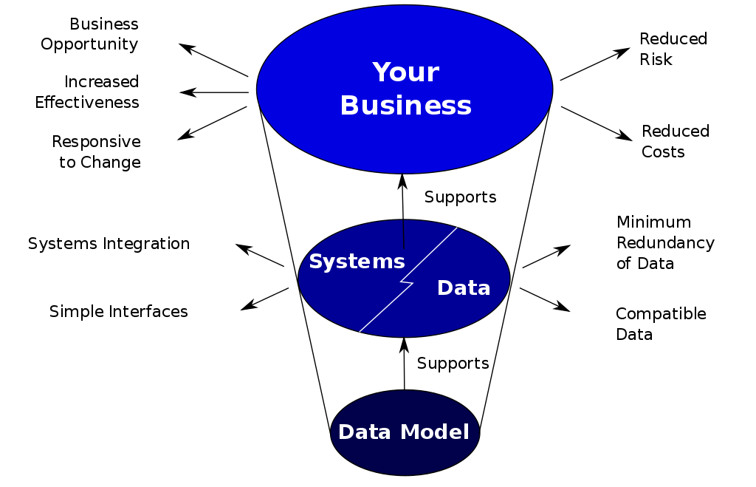

How data models deliver benefit.[[1]](https://en.wikipedia.org/wiki/Data_modeling#cite_note-MW99-1)

Data models provide a framework for [data](https://en.wikipedia.org/wiki/Data) to be used within [information systems](https://en.wikipedia.org/wiki/Information_system) by providing specific definition and format. If a data model is used consistently across systems then compatibility of data can be achieved. If the same data structures are used to store and access data then different applications can share data seamlessly. The results of this are indicated in the diagram. However, systems and interfaces are often expensive to build, operate, and maintain. They may also constrain the business rather than support it. This may occur when the quality of the data models implemented in systems and interfaces is poor.[[1]](https://en.wikipedia.org/wiki/Data_modeling#cite_note-MW99-1)

Some common problems found in data models are:

* Business rules, specific to how things are done in a particular place, are often fixed in the structure of a data model. This means that small changes in the way business is conducted lead to large changes in computer systems and interfaces. So, business rules need to be implemented in a flexible way that does not result in complicated dependencies, rather the data model should be flexible enough so that changes in the business can be implemented within the data model in a relatively quick and efficient way.
* Entity types are often not identified, or are identified incorrectly. This can lead to replication of data, data structure and functionality, together with the attendant costs of that duplication in development and maintenance.Therefore, data definitions should be made as explicit and easy to understand as possible to minimize misinterpretation and duplication.
* Data models for different systems are arbitrarily different. The result of this is that complex interfaces are required between systems that share data. These interfaces can account for between 25-70% of the cost of current systems. Required interfaces should be considered inherently while designing a data model, as a data model on its own would not be usable without interfaces within different systems.
* Data cannot be shared electronically with customers and suppliers, because the structure and meaning of data has not been standardised. To obtain optimal value from an implemented data model, it is very important to define standards that will ensure that data models will both meet business needs and be consistent.[[1]](https://en.wikipedia.org/wiki/Data_modeling#cite_note-MW99-1)

### Conceptual, logical and physical schemas

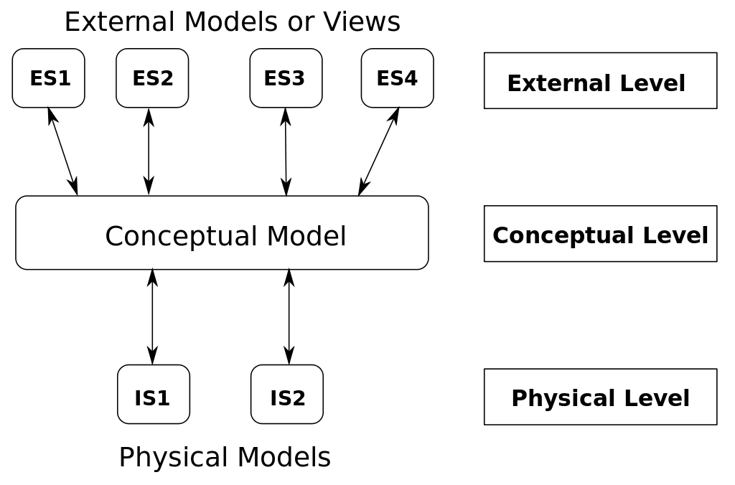

The ANSI/SPARC three level architecture. This shows that a data model can be an external model (or view), a conceptual model, or a physical model. This is not the only way to look at data models, but it is a useful way, particularly when comparing models.[[1]](https://en.wikipedia.org/wiki/Data_modeling#cite_note-MW99-1)

In 1975 [ANSI](https://en.wikipedia.org/wiki/American_National_Standards_Institute) described three kinds of data-model *instance*:[[5]](https://en.wikipedia.org/wiki/Data_modeling" \l "cite_note-5)

* [Conceptual schema](https://en.wikipedia.org/wiki/Conceptual_schema): describes the semantics of a domain (the scope of the model). For example, it may be a model of the interest area of an organization or of an industry. This consists of entity classes, representing kinds of things of significance in the domain, and relationships assertions about associations between pairs of entity classes. A conceptual schema specifies the kinds of facts or propositions that can be expressed using the model. In that sense, it defines the allowed expressions in an artificial "language" with a scope that is limited by the scope of the model. Simply described, a conceptual schema is the first step in organizing the data requirements.
* [Logical schema](https://en.wikipedia.org/wiki/Logical_schema): describes the structure of some domain of information. This consists of descriptions of (for example) tables, columns, object-oriented classes, and XML tags. The logical schema and conceptual schema are sometimes implemented as one and the same.[[2]](https://en.wikipedia.org/wiki/Data_modeling#cite_note-RS001-2)
* [Physical schema](https://en.wikipedia.org/wiki/Physical_schema): describes the physical means used to store data. This is concerned with partitions, CPUs, [tablespaces](https://en.wikipedia.org/wiki/Tablespace), and the like.

According to ANSI, this approach allows the three perspectives to be relatively independent of each other. Storage technology can change without affecting either the logical or the conceptual schema. The table/column structure can change without (necessarily) affecting the conceptual schema. In each case, of course, the structures must remain consistent across all schemas of the same data model.

### Data modeling process

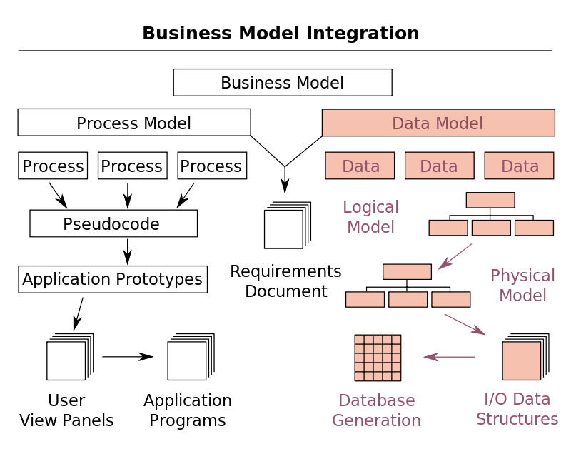

Data modeling in the context of [Business Process](https://en.wikipedia.org/wiki/Business_process) Integration.[[6]](https://en.wikipedia.org/wiki/Data_modeling#cite_note-SS93-6)

In the context of [business process integration](https://en.wikipedia.org/wiki/Business_process_modeling#Business_process_integration) (see figure), data modeling complements [business process modeling](https://en.wikipedia.org/wiki/Business_process_modeling), and ultimately results in database generation.[[6]](https://en.wikipedia.org/wiki/Data_modeling#cite_note-SS93-6)

The process of designing a database involves producing the previously described three types of schemas - conceptual, logical, and physical. The database design documented in these schemas are converted through a [Data Definition Language](https://en.wikipedia.org/wiki/Data_Definition_Language), which can then be used to generate a database. A fully attributed data model contains detailed attributes (descriptions) for every entity within it. The term "database design" can describe many different parts of the design of an overall [database system](https://en.wikipedia.org/wiki/Database_system). Principally, and most correctly, it can be thought of as the logical design of the base data structures used to store the data. In the [relational model](https://en.wikipedia.org/wiki/Relational_model) these are the [tables](https://en.wikipedia.org/wiki/Table_(database)) and [views](https://en.wikipedia.org/wiki/View_(database)). In an [object database](https://en.wikipedia.org/wiki/Object_database) the entities and relationships map directly to object classes and named relationships. However, the term "database design" could also be used to apply to the overall process of designing, not just the base data structures, but also the forms and queries used as part of the overall database application within the [Database Management System](https://en.wikipedia.org/wiki/Database_management_system) or DBMS.

In the process, system [interfaces](https://en.wikipedia.org/wiki/Interface_(computer_science)) account for 25% to 70% of the development and support costs of current systems. The primary reason for this cost is that these systems do not share a common data model. If data models are developed on a system by system basis, then not only is the same analysis repeated in overlapping areas, but further analysis must be performed to create the interfaces between them. Most systems within an organization contain the same basic data, redeveloped for a specific purpose. Therefore, an efficiently designed basic data model can minimize rework with minimal modifications for the purposes of different systems within the organization[[1]](https://en.wikipedia.org/wiki/Data_modeling" \l "cite_note-MW99-1)

### Modeling methodologies

Data models represent information areas of interest. While there are many ways to create data models, according to [Len Silverston](https://en.wikipedia.org/w/index.php?title=Len_Silverston&action=edit&redlink=1) (1997)[[7]](https://en.wikipedia.org/wiki/Data_modeling" \l "cite_note-SIG97-7) only two modeling methodologies stand out, top-down and bottom-up:

* Bottom-up models or View Integration models are often the result of a [reengineering](https://en.wikipedia.org/wiki/Reengineering_(software)) effort. They usually start with existing data structures forms, fields on application screens, or reports. These models are usually physical, application-specific, and incomplete from an [enterprise perspective](https://en.wikipedia.org/wiki/Enterprise_architecture). They may not promote data sharing, especially if they are built without reference to other parts of the organization.[[7]](https://en.wikipedia.org/wiki/Data_modeling#cite_note-SIG97-7)
* Top-down [logical data models](https://en.wikipedia.org/wiki/Logical_data_model), on the other hand, are created in an abstract way by getting information from people who know the subject area. A system may not implement all the entities in a logical model, but the model serves as a reference point or template.[[7]](https://en.wikipedia.org/wiki/Data_modeling#cite_note-SIG97-7)

Sometimes models are created in a mixture of the two methods: by considering the data needs and structure of an application and by consistently referencing a subject-area model. Unfortunately, in many environments the distinction between a logical data model and a physical data model is blurred. In addition, some [CASE](https://en.wikipedia.org/wiki/Computer-aided_software_engineering) tools don’t make a distinction between logical and [physical data models](https://en.wikipedia.org/wiki/Physical_data_model).[[7]](https://en.wikipedia.org/wiki/Data_modeling#cite_note-SIG97-7)

### Entity relationship diagrams

Main article: [Entity-relationship model](https://en.wikipedia.org/wiki/Entity-relationship_model)

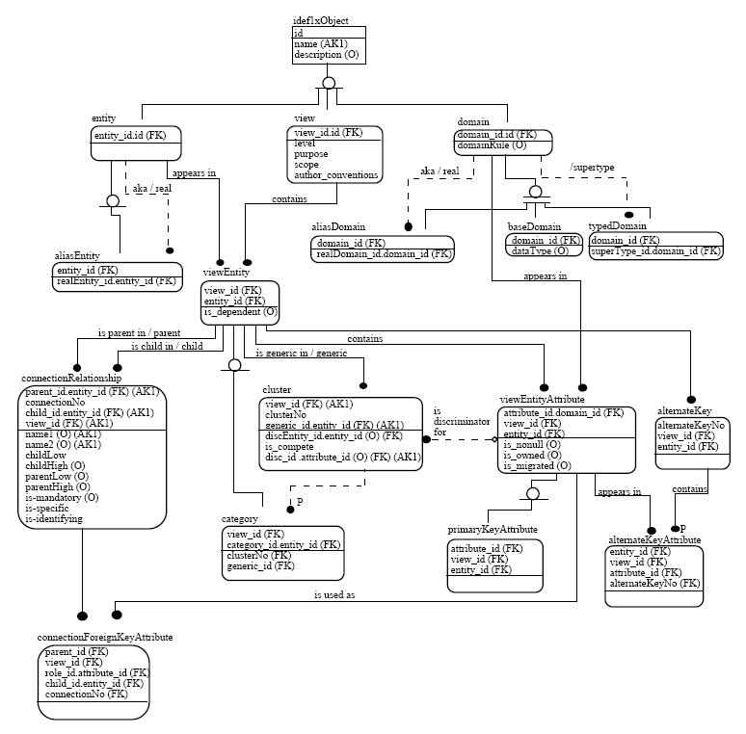

Example of an [IDEF1X](https://en.wikipedia.org/wiki/IDEF1X) Entity relationship diagrams used to model IDEF1X itself. The name of the view is mm. The domain hierarchy and constraints are also given. The constraints are expressed as sentences in the formal theory of the meta model.[[8]](https://en.wikipedia.org/wiki/Data_modeling#cite_note-FIPS184-8)

There are several notations for data modeling. The actual model is frequently called "Entity relationship model", because it depicts data in terms of the entities and relationships described in the [data](https://en.wikipedia.org/wiki/Data).[[4]](https://en.wikipedia.org/wiki/Data_modeling#cite_note-WBD04-4) An entity-relationship model (ERM) is an abstract conceptual representation of structured data. Entity-relationship modeling is a relational schema [database modeling](https://en.wikipedia.org/wiki/Database_model) method, used in [software engineering](https://en.wikipedia.org/wiki/Software_engineering) to produce a type of [conceptual data model](https://en.wikipedia.org/wiki/Conceptual_schema) (or [semantic data model](https://en.wikipedia.org/wiki/Semantic_data_model)) of a system, often a [relational database](https://en.wikipedia.org/wiki/Relational_database), and its requirements in a [top-down](https://en.wikipedia.org/wiki/Top-down_and_bottom-up_design) fashion.

These models are being used in the first stage of [information system](https://en.wikipedia.org/wiki/Information_system) design during the [requirements analysis](https://en.wikipedia.org/wiki/Requirements_analysis) to describe information needs or the type of [information](https://en.wikipedia.org/wiki/Information) that is to be stored in a [database](https://en.wikipedia.org/wiki/Database). The [data modeling](https://en.wikipedia.org/wiki/Data_model) technique can be used to describe any [ontology](https://en.wikipedia.org/wiki/Ontology_(computer_science)) (i.e. an overview and classifications of used terms and their relationships) for a certain [universe of discourse](https://en.wikipedia.org/wiki/Domain_of_discourse) i.e. area of interest.

Several techniques have been developed for the design of data models. While these methodologies guide data modelers in their work, two different people using the same methodology will often come up with very different results. Most notable are:

* [Bachman diagrams](https://en.wikipedia.org/wiki/Bachman_diagram)
* [Barker's notation](https://en.wikipedia.org/wiki/Barker%27s_notation)
* [Chen's Notation](https://en.wikipedia.org/wiki/Entity-relationship_model)
* [Data Vault Modeling](https://en.wikipedia.org/wiki/Data_Vault_Modeling)
* [Extended Backus–Naur form](https://en.wikipedia.org/wiki/Extended_Backus%E2%80%93Naur_form)
* [IDEF1X](https://en.wikipedia.org/wiki/IDEF1X)
* [Object-relational mapping](https://en.wikipedia.org/wiki/Object-relational_mapping)
* [Object-Role Modeling](https://en.wikipedia.org/wiki/Object-Role_Modeling)
* [Relational Model](https://en.wikipedia.org/wiki/Relational_Model)
* [Relational Model/Tasmania](https://en.wikipedia.org/wiki/Relational_Model/Tasmania)

### Generic data modeling

Main article: [Generic data model](https://en.wikipedia.org/wiki/Generic_data_model)

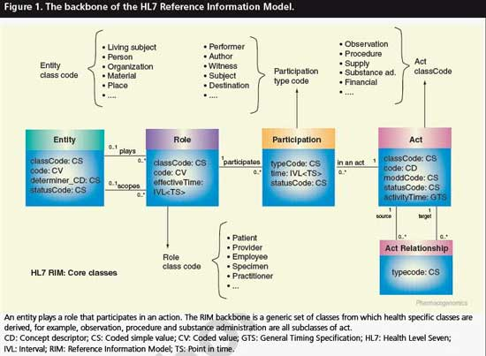

Example of a Generic data model.[[9]](https://en.wikipedia.org/wiki/Data_modeling#cite_note-9)

Generic data models are generalizations of conventional [data models](https://en.wikipedia.org/wiki/Data_model). They define standardized general relation types, together with the kinds of things that may be related by such a relation type. The definition of generic data model is similar to the definition of a natural language. For example, a generic data model may define relation types such as a 'classification relation', being a [binary relation](https://en.wikipedia.org/wiki/Binary_relation) between an individual thing and a kind of thing (a class) and a 'part-whole relation', being a binary relation between two things, one with the role of part, the other with the role of whole, regardless the kind of things that are related.

Given an extensible list of classes, this allows the classification of any individual thing and to specify part-whole relations for any individual object. By standardization of an extensible list of relation types, a generic data model enables the expression of an unlimited number of kinds of facts and will approach the capabilities of natural languages. Conventional data models, on the other hand, have a fixed and limited domain scope, because the instantiation (usage) of such a model only allows expressions of kinds of facts that are predefined in the model.

### Semantic data modeling

Main article: [Semantic data model](https://en.wikipedia.org/wiki/Semantic_data_model)

The logical data structure of a DBMS, whether hierarchical, network, or relational, cannot totally satisfy the requirements for a conceptual definition of data because it is limited in scope and biased toward the implementation strategy employed by the DBMS. That is unless the semantic data model is implemented in the database on purpose, a choice which may slightly impact performance but generally vastly improves productivity.

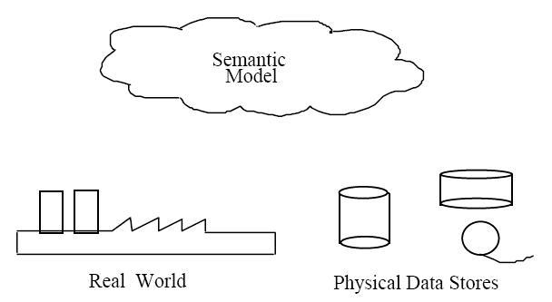

Semantic data models.[[8]](https://en.wikipedia.org/wiki/Data_modeling#cite_note-FIPS184-8)

Therefore, the need to define data from a conceptual view has led to the development of [semantic data modeling](https://en.wikipedia.org/wiki/Semantic_data_model) techniques. That is, techniques to define the meaning of data within the context of its interrelationships with other data. As illustrated in the figure the real world, in terms of resources, ideas, events, etc., are symbolically defined within physical data stores. A semantic data model is an [abstraction](https://en.wikipedia.org/wiki/Abstraction_(computer_science)) which defines how the stored symbols relate to the real world. Thus, the model must be a true representation of the real world.[[8]](https://en.wikipedia.org/wiki/Data_modeling#cite_note-FIPS184-8)

A semantic data model can be used to serve many purposes, such as:[[8]](https://en.wikipedia.org/wiki/Data_modeling#cite_note-FIPS184-8)

* planning of data resources
* building of shareable databases
* evaluation of vendor software
* integration of existing databases

The overall goal of semantic data models is to capture more meaning of data by integrating relational concepts with more powerful [abstraction](https://en.wikipedia.org/wiki/Abstraction_(computer_science)) concepts known from the [Artificial Intelligence](https://en.wikipedia.org/wiki/Artificial_intelligence) field. The idea is to provide high level modeling primitives as integral part of a data model in order to facilitate the representation of real world situations.[[10]](https://en.wikipedia.org/wiki/Data_modeling#cite_note-10)